Elijah Andrushenko

CPTS 440

Artificial Intelligence

09-19-2019

Homework 4

1.

A) MAX will choose a2 since that will return the maximal result in optimal play.

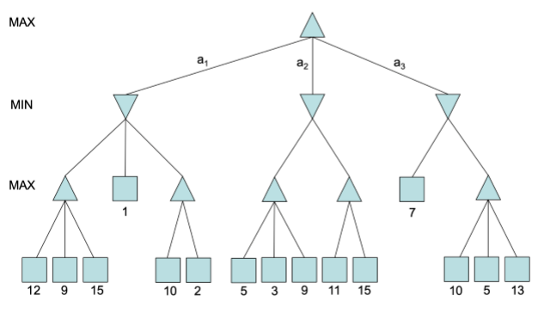

9

7

9

1

13

15

9

13

10

15

11

10

15

12

7

5

9

3

5

2

9

1

10

15

B) MAX should choose a2 since that will return the maximal result in optimal play.

9

7

9

X

X

X

X

7

11

9

X

11

9

3

5

1

10

X

10

1

15

15

9

12

2.

A)

R1: Like(Checkers) ⇒ Like(Chess)

R2: Like(Computers) ⇒ Like(Coding)

R3: (Like(Chess) ^ Like(Coding)) ⇒ Learn(AI)

R4: Learn(AI) ⇒ (Rich ^ Famous)

R5: Like(Checkers)

R6: Like(Computers)

B)

R1: ¬Like(Checkers) v Like(Chess)

R2: ¬Like(Computers) v Like(Coding)

R3: ¬Like(Chess) v ¬Like(Coding) v Learn(AI)

R4: (¬Learn(AI) v Rich) ^ (¬Learn(AI) v Famous)

R5: Like(Checkers)

R6: Like(Computers)

C)

|  |  |  |
| --- | --- | --- |
| **Step** | **CNF** | **Steps Used** |
| 1 | ¬Like(Checkers) v Like(Chess) | 0 |
| 2 | ¬Like(Computers) v Like(Coding) | 0 |
| 3 | ¬Like(Chess) v ¬Like(Coding) v Learn(AI) | 0 |
| 4 | (¬Learn(AI) v Rich) ^ (¬Learn(AI) v Famous) | 0 |
| 5 | Like(Checkers) | 0 |
| 6 | Like(Computers) | 0 |
| 7 | ¬Rich | 0 |
| 8 | Like(Chess) | 1, 5 |
| 9 | Like(Coding) | 2, 6 |
| 10 | Learn(AI) | 3, 8, 9 |
| 11 | ¬Learn(AI) v Rich | 4 |
| 12 | Rich | 10, 11 |
| 13 | **Proof by Refutation** | 7, 12 |